**TITLE: SMART COOKER WHISTLE COUNTER WITH AUTO SHUT-OFF**

**ABSTRACT**

With the increasing demand for smart kitchen automation, this research presents the development of a **Smart Cooker Whistle Counter with Auto Switch Off**. The device is designed to enhance cooking efficiency and safety by detecting and counting pressure cooker whistles, then automatically turning off the heat source once the preset count is reached. It integrates a **sound sensor** to capture whistle sounds, a **microcontroller** to process the count, and a **relay module** to control the gas stove or induction unit. By automating the cooking process, the system minimizes human intervention, prevents overcooking, and conserves energy. The invention is compatible with various pressure cooker models and allows users to set custom whistle counts based on specific cooking needs. This innovative solution streamlines the cooking experience, ensuring convenience, precision, and enhanced kitchen safety.

T. Mani Sai Lokesh Dr. Arjun Pandian

**FIELD OF INVENTION:**

The invention pertains to advancements in kitchen automation and smart cooking solutions, specifically in the development of an intelligent whistle counter integrated with an automatic switch-off mechanism for pressure cookers, ensuring safe operation without causing damage to induction stoves or other cooking appliances.

**BACKGROUND OF INVENTION:**

Cooking with a pressure cooker requires careful monitoring, as the number of whistles determines the cooking duration. Manually counting whistles can be inconvenient, leading to errors such as undercooking or overcooking. Traditional kitchen appliances lack automation to track and respond to pressure cooker whistles. A smart solution is needed to ensure precision in cooking while minimizing human effort.

Existing kitchen automation systems do not provide dedicated features for detecting pressure cooker whistles and automatically controlling the heat source. Over-reliance on manual tracking can lead to energy wastage and potential food spoilage. Integrating a whistle detection mechanism with an auto switch-off feature can enhance cooking safety. This innovation addresses the need for a user-friendly, intelligent cooking assistant.

Modern smart kitchen devices focus on convenience, safety, and energy efficiency, yet pressure cooking remains largely manual. By developing a whistle counter with an automatic switch-off mechanism, the cooking process can be optimized. This system not only ensures accurate cooking times but also prevents excessive gas or electricity consumption, making it a valuable addition to smart kitchens.

**SUMMARY OF INVENTION:**

The **Smart Cooker Whistle Counter with Auto Switch Off** is an intelligent kitchen automation device designed to detect and count pressure cooker whistles while automatically switching off the heat source. It integrates a **sound sensor**, **microcontroller**, and **relay system** to ensure precise cooking without manual monitoring. Once the preset whistle count is reached, the system turns off the gas stove or induction cooker, preventing overcooking and saving energy. This innovation enhances cooking efficiency, reduces human effort, and ensures safety, making it a valuable addition to modern smart kitchens.

T. Mani Sai Lokesh Dr. Arjun Pandian

**SPECIFICATION**

* **Sound Detection Mechanism**: The device uses a high-sensitivity sound sensor to accurately detect and count pressure cooker whistles, ensuring precision in cooking.
* **Microcontroller Processing**: A microcontroller processes the whistle count and sends a signal to trigger the switch-off mechanism once the preset count is achieved.
* **Automatic Switch-Off System**: A relay module is integrated to turn off the gas stove or induction cooker, preventing overcooking and saving energy.
* **User Customization**: The system allows users to set the desired whistle count based on specific cooking requirements.
* **Compatibility**: Designed to work with various pressure cooker models and heat sources, including gas stoves and induction cookers.
* **Energy Efficient**: Automating the switch-off process minimizes gas or electricity consumption, contributing to energy conservation.
* **Safety Features**: Reduces the risk of food burning and ensures unattended cooking without compromising safety.
* **Compact and Durable Design**: Built with lightweight and heat-resistant materials to ensure durability, ease of installation, and long-term performance.
* LED or Display Indicator: Includes an LED or small display to show the whistle count and status, providing visual feedback for user convenience.
* **Real-Time Monitoring**: Continuously tracks whistle sounds and updates the count in real-time, ensuring precise cooking control.

T. Mani Sai Lokesh Dr. Arjun Pandian

**DESCRIPTION**

The **Smart Cooker Whistle Counter with Auto Switch Off** is an advanced kitchen automation device designed to simplify pressure cooking. It accurately detects and counts the number of whistles produced by a pressure cooker using a **high-sensitivity sound sensor**. The whistle count is processed by a **microcontroller**, which then triggers a **relay module** to turn off the gas stove or induction cooker once the preset count is reached. This automated process ensures that food is cooked to perfection while eliminating the need for manual monitoring.

The system is designed to be **compatible with various pressure cooker models** and heat sources, including gas stoves and induction cookers. Users can set a specific whistle count based on their cooking preferences, making the device highly customizable. Additionally, the system features **a visual indicator such as an LED display** to show the whistle count and operation status in real-time. This enhances user convenience and ensures a seamless cooking experience.

By integrating **safety features and energy efficiency**, this smart device prevents food from burning, reduces gas and electricity consumption, and minimizes the risks of kitchen hazards. Its **compact and durable design** ensures long-term performance while being easy to install and use. This innovation enhances cooking precision and convenience, making it a valuable addition to modern kitchens.

**3D Image**

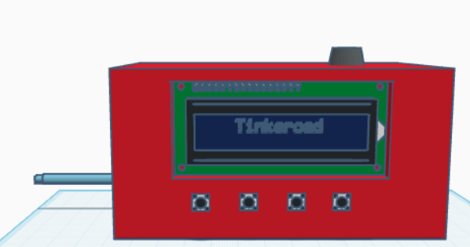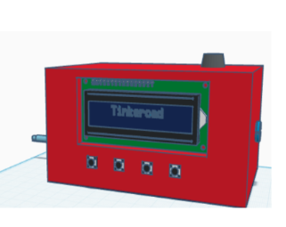

**FIGURE: Smart Cooker Whistle Counter With Auto Shut-Off**

T. Mani Sai Lokesh Dr. Arjun Pandian

**Product Image :**

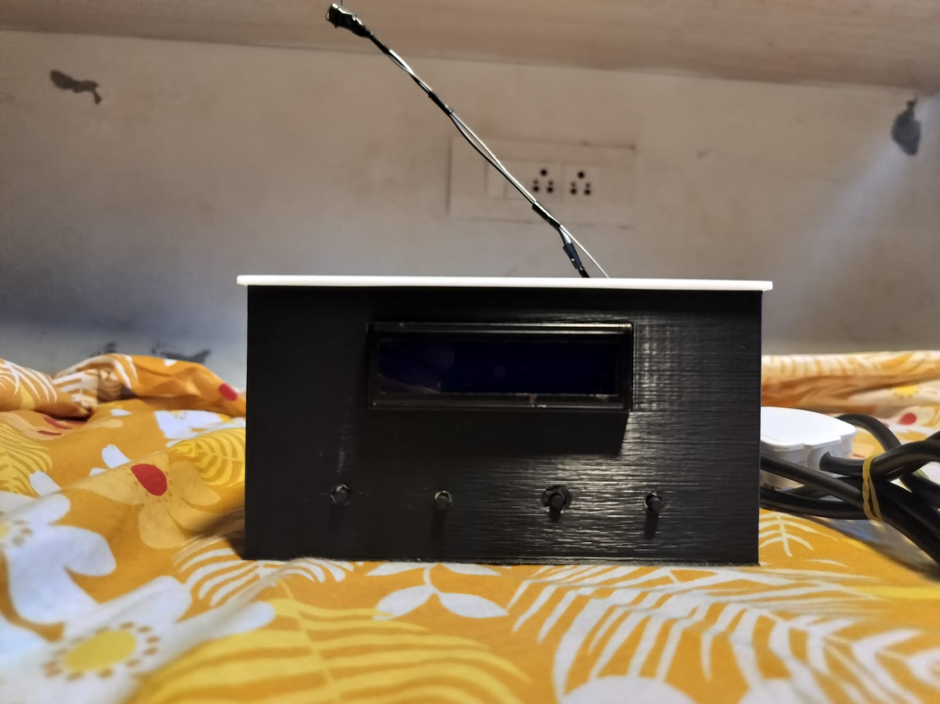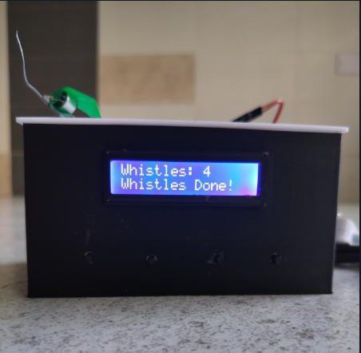

**WE CLAIM**

* **Claim**: The smart cooker whistle counter accurately detects and counts pressure cooker whistles, ensuring precise cooking results.
* **Claim**: The device automatically switches off the heat source once the preset whistle count is reached, preventing overcooking.
* **Claim**: The system is compatible with gas stoves and induction cookers, ensuring safe operation without causing any damage.
* **Claim**: The device features a buzzer alert that activates once the target whistle count is reached, notifying the user that cooking is complete.
* **Claim**: The integration of a real-time display or LED indicator provides visual feedback on the whistle count and operational status.
* **Claim**: The smart whistle counter minimizes human intervention, enhancing kitchen safety, energy efficiency, and cooking precision.
* **Claim**: The use of a relay-based switch-off mechanism contributes to energy conservation by reducing unnecessary gas or electricity consumption.

T. Mani Sai Lokesh Dr. Arjun Pandian